St. Emily School
MEETING MINUTES
7:00 PM – 8:00 PM
January 26, 2023

TOPIC: To foster Catholic education, advise administration and support the mission of  St. Emily Catholic School. | Attendees: School Advisory Board Members  Facilitator: School Advisory Board President, Mike Burns  Note Keeper: Amy Cattapan  Timekeeper: Father Presta

MEETING MINUTES:

7:02 p.m. Fr. Presta began the meeting with prayer.

Pastor’s Report:
- 2023 Dates for Sacraments at St. Emily:
- First Reconciliation: Monday, Feb. 27, Tuesday, February 28, 6:30 p.m. Three priests will be available each evening.
- Confirmation: March 12, 2:00 p.m., Bishop Grob will confirm the students, over 90 students
- First Communion: Saturday, April 29 at 11:00 a.m., and Sunday, April 30, at 1:30 p.m.
- Teaching religion - Fr. Hank teaches seventh grade once a week; Fr. Hank and Fr. Presta will spend with second graders in February before Reconciliation.
- St. Joseph’s Table – first time in three years! March 19, 12:00-3:00 p.m. All are welcome. Admission is free. Monetary donations go to St. Vincent de Paul
- New organ for the church - A new Rodger organ has been purchased and installed in our church. The organ was made possible because of the To Teach Who Chris is Campaign held a few years ago. The old organ was installed about fifty years ago when the church was built.

Principal’s Report:
- Teachers are administering the i-Ready mid-year diagnostics now to measure growth in math and reading. The testing window is from Jan. 9 – Feb. 10. Results will be sent home once the diagnostics have been completed.
- Fall Diagnostic Results:

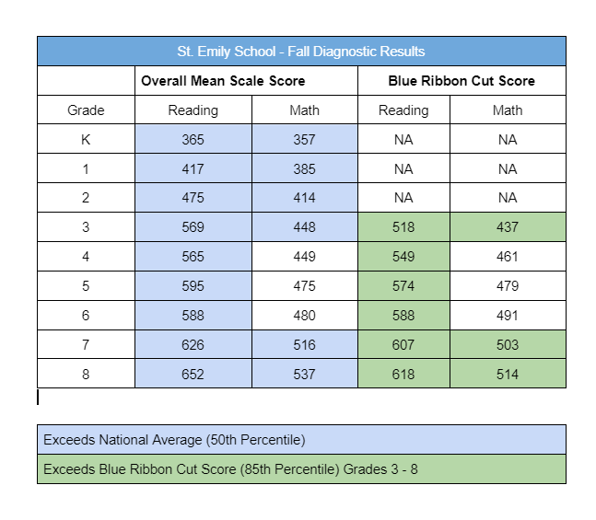
- Four interactive whiteboards on carts (two for each wing) were acquired through grant money and are being used by the teachers for instruction.
- Quarter 2 has ended, and 48 students earned a place on the honor roll:
Grade | High Honors  (All A’s) | Honors  (A’s and B’s)
5 | 4 | 7
6 | 3 | 8
7 | 10 | 11
8 | 1 | 4

- The new playground is being installed Funds from last spring’s Track-a-Thon and a donor were used to purchase it.
- Catholic Schools Week next week:
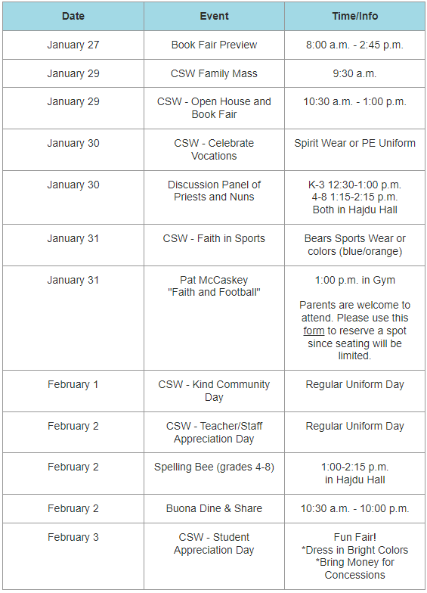
- All students in K-8 will take a field trip to the Allstate Arena on February 18 for the Chicago Wolves Get Schooled by Skates program. All students receive an interactivie workbook to learn about how hockey relates to everyday classroom subjects such as math, science, language arts, reading, and social studies.

Marketing
- New school website will debut at this Sunday’s Open House.
- Registration and re-enrollment began on January 10. Currently, 43 students are re-enrolled already.
- The purchase of a quarter page ad in the Journal results in a half-page spread with a STEM article about our school.
- Scheduled Open House/Community Visits:
Weds. Jan. 18 | 6:30 – 8:30 pm. | Pre-K Fair at Arlington Heights Library
Tues. Jan. 24 | 7:00 – 8:00 pm. | Pre-K Fair at Mt. Prospect Library
Sun. Jan. 29 | 10:30 – 1:00 pm. | CSW Open House at St. Emily
Weds. Mar. 8 | 9:00 – 10:30 am. | All school Open House during the day.
Thurs. April 20 | 6:00 – 7:00 pm. | Early Childhood Night (Pre-K – K)
- Daily postings on social media pages. The AOC marketing team described our presence as “fantastic.”
- School magnets were produced to advertise the school. Thanks to FSE for purchasing the magnets.

Athletic Report:
- Monday, January 16 0 Free Throw Contest held in gym with 7 attendees.
- We need to put on hold looking at including our third graders in our Athletic program since we only have insurance for grades 4 and up.
- Registration for spring sports opens on February 3.
- Looking to see if there is any interest in the conference for kickball as a replacement for softball. Picture Day coming up
- Next Athletic Board meeting is February 9.
- Alumni Games will be held on April 22 and the Athletic Banquet on April 27.
- Picture Day is February 26.

Development Report:
Diana Kozojed working on a grant from the Cook Foundation to update the technology in Hajdu Hall to benefit parish and school.

Finance Report:
Currently, the parish continues to be in the black. However, Christmas donations were lower than anticipated.

FSA Report:
FSA paid for yard signs for Catholic Schools Week and providing a special luncheon for the faculty and staff.

8:00 p.m. Closing Prayer

0

